**CLINICAL STUDY REPORT**

**Management of Acute Ischemic Stroke with Tenecteplase- A Real World, Multi-**

**Centered, Observational Study**

**AIM**:

The study aims to observe the safety and efficacy of Tenecteplase in patients with Acute Ischemic Stroke.

**STUDY DESIGN:**

An observational study was performed and data of 200 patients were collected prospectively using paper-based case report forms from patients who received the intravenous Tenecteplase for treatment of Acute Ischemic Stroke. The collected patient data has been utilized to determine the safety, efficacy and certain secondary outcomes of the study drug. The patients included had confirmed radiological diagnosis of Acute Ischemic Stroke with no contraindications for Tenecteplase. Patients who were diagnosed with conditions other than AIS and having contraindications to Tenecteplase were excluded.

**RESULT:**

1. **Efficacy Outcomes** included major Neurological improvement at 24 hours and Functional status on discharge. This has been analyzed by using NIHSS score which has been captured and analyzed throughout the patient stay and during discharge. In addition, mRS Score distribution has also been used. NIHSS Score (National Institutes of Health Stroke Scale (NIHSS)) is a tool developed to help physicians objectively rate severity of ischemic strokes. mRS or The Modified Rankin Score (mRS) is a 6 point disability scale which is the most widely used outcome measure in stroke clinical trials.

**Observations are described below:**

1. **NIHSS Score trend throughout patient stay:**

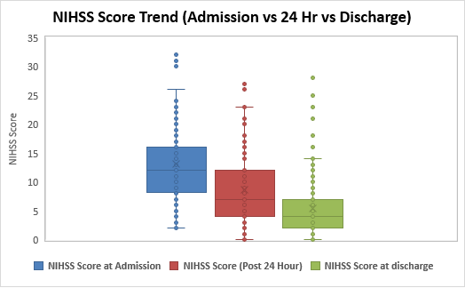

The above box plot clearly indicates a reduction in the NIHSS Score after drug administration. The mean NIHSS score of patients at the time of Admission was observed 13.33±7.15 SD, after treatment post 24 hours 8.32±6.66 SD and at the time of discharge the NIHSS Score was observed 5.42± 5.55 SD.

|  |  |  |  |  |  |  |  |  |  |  |
| --- | --- | --- | --- | --- | --- | --- | --- | --- | --- | --- |
| **NIHSS Score** | **Mean** | **SD** | **N** | **Pearson Correlation** | **df** | **t Stat** | **P(T<=t) one-tail** | **t Critical one-tail** | **P(T<=t) two-tail** | **t Critical two-tail** |
| **NIHSS Score at Admission** | 13.33 | 7.15 | 154 | 0.50 | 153 | 8.98 | 0.00 | 1.65 | 0.00 | 1.98 |
| **NIHSS Score (Post 24 Hour)** | 8.32 | 6.66 | 154 |
| **NIHSS Score at Admission** | 13.33 | 7.15 | 154 | 0.36 | 153 | 13.45 | 0.00 | 1.65 | 0.00 | 1.98 |
| **NIHSS Score at discharge** | 5.42 | 5.55 | 154 |
| **NIHSS Score (Post 24 Hour)** | 8.32 | 6.66 | 154 | 0.68 | 153 | 7.25 | 0.00 | 1.65 | 0.00 | 1.98 |
| **NIHSS Score at discharge** | 5.42 | 5.55 | 154 |

Based on the above paired t-tests, we can conclude that there is a significant reduction in the NIHSS Score after drug administration.

1. **NIHSS Score at discharge:**

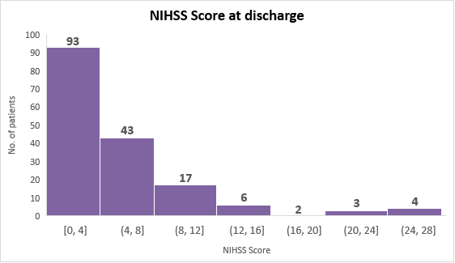

The above distribution of NIHSS score at discharge indicates that the majority of patients who received the study drug were able to achieve a lower NIHSS during discharge.

55.36% Patients having 0-4 range of NIHSS Score, 25.59% patients observed 4-8 NIHSS score, while 10.12% observed 8-12 range of NIHSS score and remaining 8.93% between 12-28 NIHSS score.

1. **mRS Score distribution:**

|  |  |  |  |  |  |  |
| --- | --- | --- | --- | --- | --- | --- |
| **mRS Score** | **0** | **1** | **2** | **3** | **4** | **5** |
| **Count (Percentage)** | 25 (17.86%) | 46 (32.86%) | 23 (16.43%) | 14 (10%) | 9 (6.43%) | 23 (16.43%) |

The legend in the above chart indicates the mRS Scores ranging from 0 to 5 and the summary shows the percentage of patients respective to the scores. The mRS score distribution also indicates a similar trend as above, with 51% patients having 0-1 scores and 23% patients having 4-5 scores.

Below is a tabular representation of mean and standard deviations observed in the efficacy data points discussed above:

|  |  |
| --- | --- |
| **Parameters** | **Mean ± SD** |
| **NIHSS Score at Admission** | 13.33 ± 7.15 |
| **NIHSS Score (Post 24 Hour)** | 8.32 ± 6.66 |
| **NIHSS Score at discharge** | 5.42 ± 5.55 |
| **mRS** | 2.04 ± 1.70 |

1. **Safety outcomes** were measured by analyzing the prevalence of Symptomatic intracranial hemorrhage (sICH), Adverse Events, and Mortality rate.

Observations are described below:

1. **Frequency of Adverse events:**

From the data received of 200 patients, 121 data had mentioned the adverse events. In 106 patients adverse events were not observed after the treatment while there were 15 patients who experienced an adverse event during the study. 5 of those adverse events were not caused directly by the study drug and 10 were caused by the study drug. Significantly 85.8% of patients not experienced any kind of adverse events while 9.4% of patients shows adverse events related to drug and 4.8 due to other reasons.

1. **Mortality rate:**

There were 2 deaths during the study, the reasons are made known in the above visual. Based on the data, the mortality rate is significantly low around 1%.

1. **Secondary Outcomes** include age distribution, gender ratio, Co-morbidities distribution and time duration between stroke onset and administration of the drug (Tenecteplase). Observations are described below:
2. **Age distribution**

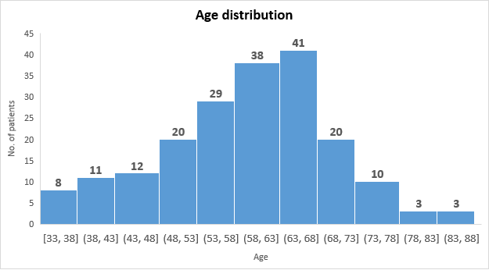

Age distribution graph shows that maximum AIS is seen in ages between 58-68 years (40.51%).

1. **Gender ratio:**

The gender ratio in the above chart suggests that acute ischemic stroke might be affecting males more than females.

1. **Co-morbidities frequency distribution:**

The above chart shows the distribution of common co-morbidities that the patients with acute ischemic stroke have.

Major co-morbidities were observed are Hypertension (58.5%) Diabetes (41%), Smoker (19%), Hyperlipidemia (13%), Atrial Fibrillation (6%). Heart Failure (4.5%) and Previous stroke (5%).

1. **Time duration between stroke onset and administration of the drug (Tenecteplase):**

The above data suggest that the majority of the patients have been administered within 5 hours of stroke onset. 81.5% of patients received the drug after the onset of stroke within 3 hours, 9% patients received between 3-4.5 hours of duration while 9.5% received the drug after 4.5 hours of stroke onset.

1. **Patient Retention Time**

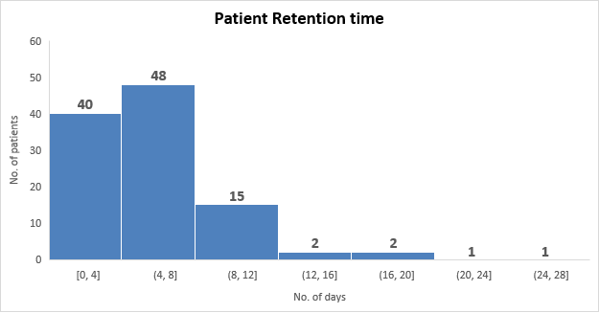

The above chart suggests that the retention time for the site was mostly within 12 days from date of admission to date of discharge.

Below is a tabular representation of mean and standard deviations observed in the secondary data points discussed above:

|  |  |
| --- | --- |
| **Parameters** | **Mean ± SD** |
| **Age (yrs)** | 59.61 ± 10.63 |
| **Weight (kgs)** | 67.72 ± 9.74 |
| **Time between stroke onset and drug administration (hrs)** | 2.58 ± 3.56 |
| **Patient Retension Time in Hospital (Days)** | 6.05 ± 4.25 |

Below is a tabular representation showing the frequency distribution of the secondary outcomes discussed above:

|  |  |  |
| --- | --- | --- |
|  | | **N (%)** |
| **Sex** | Female | 57 (29.38%) |
| Male | 137 (70.62%) |
| **Time between stroke onset and drug administration distribution (hours)** | 0-3 hours | 163 (81.5%) |
| 3-4.5 hours | 18 (9%) |
| 4.5 hours and above | 19 (9.5%) |
| **Hypertension** | No | 83 (41.5%) |
| Yes | 117 (58.5%) |
| **Diabetes** | No | 118 (59%) |
| Yes | 82 (41%) |
| **Smoker** | No | 162 (81%) |
| Yes | 38 (19%) |
| **Hyperlipidemia** | No | 174 (87%) |
| Yes | 26 (13%) |
| **Atrial fibrillation** | No | 188 (94%) |
| Yes | 12 (6%) |
| **Heart failure** | No | 191 (95.5%) |
| Yes | 9 (4.5%) |
| **Previous Stroke** | No | 190 (95%) |
| Yes | 10 (5%) |

**CONCLUSION:**